Week 1 Lab 1 workflow: migrating a VM from AWS and from Azure to Google Compute Engine
This document is the process view of Lab 1. The two lab guides (AWS variant, Azure variant) give every command; this one shows the workflow, how long each step takes, the console (UI) path for people who prefer clicking to typing, and the three scripts that run the whole thing.
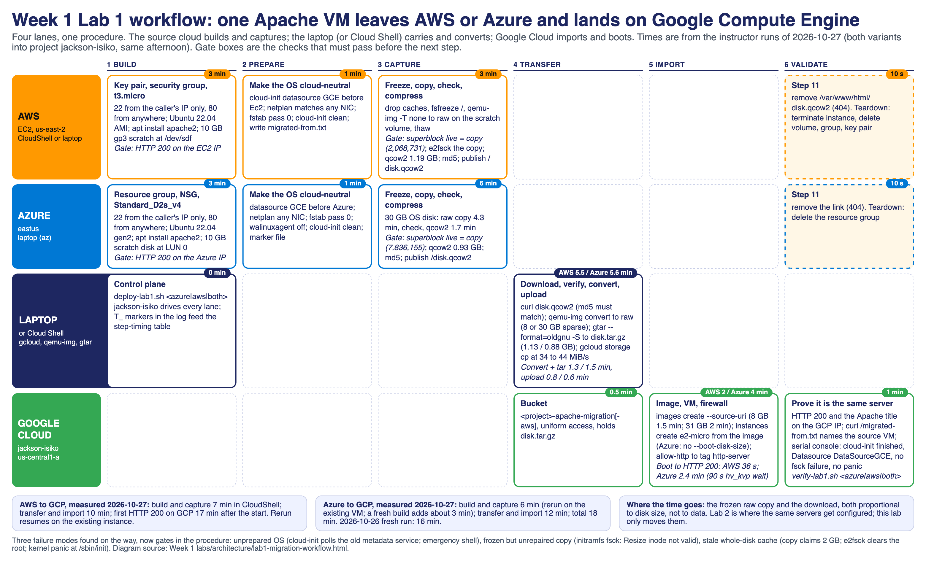
Times below were measured on 2026-10-27 with both variants running into GCP project jackson-isiko the same afternoon (the two downloads shared one home connection, so transfer times are a little pessimistic). The scripts now print this table themselves at the end of every run (Step timing (min:sec)), so bring your own numbers to the debrief.

1. The workflow in one page
Phase | What happens | Where | Gate before the next phase
1 Build | Create the source VM with Apache; open 22 to the caller only, 80 to everyone; attach a 10 GB scratch disk | Source cloud | HTTP 200 on the source IP
2 Prepare | Make the OS cloud-neutral: cloud-init datasource order (GCE first), netplan for any NIC, fstab pass 0, agent off, cloud-init clean, write migrated-from.txt | On the VM | PREP_DONE
3 Capture | Drop caches, freeze /, raw copy of the whole root device with qemu-img -T none, thaw; compare the copy's superblock with the live root; e2fsck the copy; compress to qcow2; publish at /disk.qcow2 | On the VM | superblock block count: live=N copy=N, md5 recorded
4 Transfer | Download, verify md5, convert to raw, GNU tar oldgnu sparse to disk.tar.gz, upload to a bucket | Laptop or Cloud Shell | md5 matches
5 Import | images create --source-uri, instances create from the image, firewall rule for tag http-server | Google Cloud | image READY
6 Validate | HTTP 200 and the Apache title on the GCP IP; migrated-from.txt names the source; serial console shows Datasource DataSourceGCE, no fsck failure, no panic; remove the public link on the source (Step 11) | Laptop | both pages open side by side

The procedure is identical for both clouds. Only the build phase and the device names differ: Azure exposes /dev/disk/azure/root and scsi1/lun0; an EC2 t3.micro exposes /dev/nvme0n1 (root) and /dev/nvme1n1 (scratch); a t2.micro shows xvda and xvdf.

2. Time per step

AWS to GCP (account Ensign Software Engineering Live, us-east-2, CloudShell build)
Step | Measured | Notes
Key pair, security group, instance running | 1 min | t3.micro, Ubuntu 22.04 AMI, default VPC
SSH ready, apt install apache2, HTTP 200 | 2 min | Apache page Last-Modified 20:39:23Z on a 20:36 start
Attach 10 GB gp3 scratch, Step 6 prep | 1 min | marker written 20:50Z
Freeze, raw copy of 8 GB, superblock check, e2fsck, qcow2 | 3 min | qcow2 1,186,012,160 bytes at 20:53Z; live=2068731 copy=2068731
Download 1.19 GB qcow2 to the laptop | 5.5 min | 14:54:48 to 15:00:17 local, shared with the Azure download
Convert to raw (8 GB sparse) and tar | 1.3 min | disk.tar.gz 1,132,519,603 bytes
Upload to gs://jackson-isiko-apache-migration-aws | 0.8 min | 34 MiB/s
images create apacheserver-image-aws | 1.5 min | 8 GB image READY
instances create apacheserver-gcp-aws (e2-micro, 10 GB boot disk) | 0.5 min | created 15:03:56
Boot to first HTTP 200 | 36 s | cloud-init finished at 20 s uptime, DataSourceGCE
Total, start to the page on GCP | 17 min | build and capture 7, transfer and import 10

Azure to GCP (subscription Ensign College - School Card, eastus, laptop build)
Step | Measured | Notes
Resource group, NSG rules, VM running | 2 min | Standard_D2s_v4, Ubuntu 22.04 gen2, created 19:57:27Z, booted 19:57:49Z
SSH ready, apt install apache2, HTTP 200 | 1 min | 2026-10-26 fresh run; on 2026-10-27 the first SSH waited 10 min because the laptop's public IP changed, which the script now handles
Attach 10 GB scratch (LUN 0), Step 6 prep | 1 min | marker written 20:48:33Z
Freeze, raw copy of 30 GB, superblock check, e2fsck, qcow2 | 6 min | raw copy 20:48:35 to 20:52:53 (4.3 min), qcow2 to 20:54:39 (1.7 min); live=7836155 copy=7836155; qcow2 932,052,992 bytes
Download 0.93 GB qcow2 to the laptop | 5.6 min | 14:54:50 to 15:00:27 local, shared with the AWS download; 1.6 min alone on 2026-10-26
Convert to raw (30 GB sparse) and tar | 1.5 min | disk.tar.gz 877,764,275 bytes
Upload to gs://jackson-isiko-apache-migration | 0.6 min | 44 MiB/s
images create apacheserver-image | 2 min | 31 GB image READY
instances create apacheserver-gcp (e2-micro, boot disk = image size) | 0.5 min | created 15:04:46
Boot to first HTTP 200 | 2.4 min | systemd waits 90 s for the Hyper-V hv_kvp device that GCE does not have, then cloud-init finishes at 114 s, DataSourceGCE
Total, start to the page on GCP | 18 min | build and capture 6 (rerun on the existing VM), transfer and import 12; fresh run on 2026-10-26: 16 min

What drives the time: the raw copy and the download scale with the size of the disk, not the data on it (30 GB Azure OS disk vs 8 GB EC2 root). Compression brings both to about 1 GB because the servers hold about 2 GB of files. Everything else is API latency.

Evening rerun, 2026-10-27 (both variants from scratch, slow home uplink)
Same scripts, same accounts, run after the afternoon teardown so the class starts on fresh VMs. The build and capture phases took the same time as before; every network transfer took much longer because the laptop's uplink averaged 2 MiB/s instead of 34 to 44 MiB/s. The two client-side gcloud timeouts and the stalled download are now handled by the scripts (see section 7).
Step | AWS | Azure | Notes
Source VM running | 0.5 min | 2.2 min | AWS built from the us-east-1 CloudShell (the us-east-2 environment would not open a session that night)
Apache installed, HTTP 200 | 0.8 min | 1.7 min
Prep + capture (superblock check passed) | 3.3 min | 12.0 min | live=2068731 copy=2068731; live=7836155 copy=7836155
Download the qcow2 | 17.4 min | 5.5 min | the AWS download stalled at 657 MB and curl gave up; the rerun resumed it (curl -C -)
Convert to raw and tar | 1.1 min | 1.5 min
Upload to Cloud Storage | 10.9 min | 21.9 min | 2 MiB/s uplink
images create | 0.1 min | 0.1 min | both calls hit gcloud's 300 s read timeout; the image was READY on the server
instances create | 1.5 min | 6.4 min | the Azure call also timed out client side; the VM existed, the script was resumed by hand
Boot to HTTP 200 | 1.2 min | 1.9 min | cloud-init 20 s (AWS-born) and 110 s (Azure-born), DataSourceGCE
Total | 37 min | 53 min | 17 and 18 min that afternoon on a fast link

Result: apacheserver1 18.191.11.26 (us-east-2c) -> apacheserver-gcp-aws 136.64.162.16; apacheserver1 20.169.154.143 (eastus) -> apacheserver-gcp 35.253.21.229. Both pages and both migrated-from.txt markers verified with verify-lab1.sh both.

3. Console (UI) path: build and export the VM from AWS
The scripts do all of this from the CLI. These are the equivalent clicks for a student who builds in the console; the on-VM steps (prepare, capture) are always typed over SSH.
Build (Phase 1)
- Console region selector (top right): US East (Ohio) us-east-2.
- EC2 → Instances → Launch instance. Name apacheserver1. Application and OS Images: Ubuntu Server 22.04 LTS (HVM), SSD, 64-bit (x86). Instance type: t3.micro. Key pair: Create new key pair apacheserver1-key, RSA, .pem; the browser downloads it (move it to ~/.ssh/ and chmod 400). Network settings → Edit: default VPC, Auto-assign public IP Enable, Create security group apacheserver1-sg with two rules: SSH, Source My IP; HTTP, Source Anywhere-IPv4. Configure storage: 8 GiB gp3 (default). Launch instance. Note the Public IPv4 address on the instance page.
- EC2 → Volumes → Create volume. Size 10 GiB, gp3, Availability Zone = the instance's (shown on the instance page, for example us-east-2c), tag Name=apacheserver1-scratch. Create. Select it → Actions → Attach volume → the instance, device /dev/sdf.
- Instance → Connect → SSH client shows the exact command; from a terminal: ssh -i ~/.ssh/apacheserver1-key.pem ubuntu@<EC2_IP>, then Steps 3 to 4 of the guide (sudo apt update && sudo apt install -y apache2). Open http://<EC2_IP>/ in the browser: Apache2 Ubuntu Default Page. Checkpoint 1 screenshot.
Export (Phases 2 and 3, over SSH)
- Prepare the OS and capture as in the guide, Steps 6 to 8 (the exact commands are in the AWS guide). The result is http://<EC2_IP>/disk.qcow2 and an md5.
- What about AWS's own export? EC2 → AMIs → Create image followed by aws ec2 export-image --disk-image-format VMDK --s3-export-location ... produces a VMDK in S3 that GCP can import with Migrate to Virtual Machines or gcloud compute images import. It needs the vmimport IAM role, an S3 bucket and 10 to 30 minutes, and the Vocareum sandbox kills it. The lab's HTTP method needs none of that and teaches what the image carries.
- After the download: Instance → Connect again and sudo rm /var/www/html/disk.qcow2 (Step 11), or Security Groups → apacheserver1-sg → Edit inbound rules and delete the HTTP rule if the server has nothing else to show.
Teardown (Phase 6)
- Instances → select → Instance state → Terminate. Volumes → apacheserver1-scratch → Actions → Delete volume. Security Groups → apacheserver1-sg → Delete. Key Pairs → apacheserver1-key → Delete. Or bash scripts/05-cleanup-aws.sh -y in CloudShell.

4. Console (UI) path: build and export the VM from Azure
- Portal → Virtual machines → Create → Azure virtual machine. Subscription Ensign College - School Card, new resource group apacheserver1-rg, name apacheserver1, region East US, image Ubuntu Server 22.04 LTS - x64 Gen2, size Standard_D2s_v4, authentication SSH public key, username ubuntu, Generate new key pair apacheserver1-key. Inbound ports: None for now. Review + create, download the private key when prompted.
- VM → Networking → Network settings → Create port rule → Inbound. Rule 1: source My IP address, destination port 22, TCP, priority 1000, name allow-ssh-admin. Rule 2: source Any, port 80, priority 1010, name allow-http.
- VM → Disks → Create and attach a new disk. Name apacheserver1-scratch, 10 GiB, Standard HDD, LUN 0. Save.
- VM → Overview shows the public IP. SSH as ubuntu with the downloaded key; Steps 3 to 8 of the Azure guide (Apache, prepare, capture).
- Azure's own export: VM → Disks → OS disk → Disk Export → Generate URL gives a SAS link to download the VHD (30 GB, not compressed), which GCP can import with gcloud compute images import --source-file disk.vhd. The lab's method moves 1 GB instead.
- Teardown: Resource groups → apacheserver1-rg → Delete resource group (type the name).

5. Console (UI) path: import the VM into Google Cloud
The scripts do this with gcloud; here is the console equivalent (project jackson-isiko).
- Cloud Storage → Buckets → Create. Name <project>-apache-migration (or -aws), region us-central1, Uniform access control. Create. Open the bucket → Upload files → disk.tar.gz (the tar.gz you made in Phase 4; the console cannot convert a qcow2 for you, so Phase 4 stays on the laptop or in Cloud Shell).
- Compute Engine → Storage → Images → Create image. Name apacheserver-image (or apacheserver-image-aws), Source: Cloud Storage file, browse to the bucket and pick disk.tar.gz, Location: Multi-regional US, family apacheserver. Create. Wait for the status to become READY (1 to 2 minutes). Size shows 31 GB (Azure) or 8 GB (AWS).
- Compute Engine → VM instances → Create instance. Name apacheserver-gcp (or -aws), region us-central1, zone us-central1-a, machine type e2-micro. OS and storage → Change → Custom images tab → apacheserver-image; boot disk size at least the image size (31 GB for Azure; 10 GB for AWS). Networking → Firewall: tick Allow HTTP traffic (this adds the tag http-server and, if missing, the default-allow-http rule). Create.
- VPC network → Firewall → Create firewall rule (only if you did not tick Allow HTTP): name allow-http, network default, Ingress, Allow, targets Specified target tags http-server, source IPv4 ranges 0.0.0.0/0, protocols TCP 80. Create.
- VM instances → apacheserver-gcp → External IP link opens http://<GCP_IP>/: the same Apache page. Then http://<GCP_IP>/migrated-from.txt names the source VM. VM → Logs → Serial port 1 (console) shows cloud-init ... Datasource DataSourceGCE and must show no fsck failure or Kernel panic. Checkpoint 3 screenshot.
- The enterprise alternative is Compute Engine → Migrate to Virtual Machines (connect an AWS or Azure source, replicate, test-clone, cut over). It is the right tool for a fleet; the Vocareum GCP role cannot open it, and it hides exactly the OS edits this lab makes visible.
- Teardown: VM instances → delete, Images → delete, Cloud Storage → delete bucket, Firewall → delete allow-http. Or the scripts below.

6. Scripts
All three accept azure, aws or both. The per-variant scripts under each lab's scripts/ folder still work on their own.
cd "Week 1 labs/lab1-migration-workflow"
bash deploy-lab1.sh both jackson-isiko # Azure then AWS; PARALLEL=1 runs them side by side
bash verify-lab1.sh both jackson-isiko # both sides, both pages, both serial consoles
bash destroy-lab1.sh both jackson-isiko -y # teardown, then lists anything left in the project

- deploy-lab1.sh runs the variant's build script, the GCP import, Step 11, and prints the step-timing table (the build and import scripts write T_<step>=<epoch> markers to the log; the table is computed from them). Reruns resume: an existing VM, image or bucket is reused.
- Without AWS credentials on the laptop, run scripts/00-aws-all-in-one.sh in AWS CloudShell (us-east-2) once, then EC2_IP=<ip> bash deploy-lab1.sh aws jackson-isiko imports it. The AWS teardown then runs in CloudShell: bash 05-cleanup-aws.sh -y.
- verify-lab1.sh lists what exists on each side, curls both pages and the marker file, and greps each migrated VM's serial console for the datasource line and any fsck or panic.
- destroy-lab1.sh is the rollback; -n only lists.

7. What can go wrong, and the gate that catches it
Symptom on the GCP VM | Cause | Gate
Emergency shell; serial console shows Polling IMDS or DataSourceEc2 retries, no network | OS not prepared (Phase 2 skipped) | PREP_DONE line; Datasource DataSourceGCE in the console
Initramfs prompt: Resize inode not valid. UNEXPECTED INCONSISTENCY | Copy taken without e2fsck | the e2fsck summary line in the capture output
Kernel panic ... can't execute '/sbin/init' after a clean fsck | Stale whole-disk cache: the copy's superblock says 2 GB | superblock block count: live=N copy=N; the script stops with CAPTURE_STALE otherwise
Requested disk size cannot be smaller than the image size | --boot-disk-size below the image (Azure 31 GB) | the Azure import passes no size
First SSH times out on the source | The laptop's public IP changed after the rule was written | the wait loop re-points the rule
HTTP 000 for the first two minutes on the Azure-born VM | systemd waits 90 s for hv_kvp | normal; the validate loop allows 5 min
Download stops part way, curl exits, the script aborts at Step 10 | Flaky uplink (seen 2026-10-27 evening at 657 MB of 1.19 GB) | curl --retry 10 -C - resumes the same file; rerunning the import continues where it stopped
gcloud crashed (ReadTimeout) ... read timeout=300 on images create or instances create | Slow link: the API call finished server side but the client gave up waiting | the import scripts now poll the image for READY and the VM for RUNNING instead of trusting the call
CloudShell shows Failed to open session or Unable to create the environment | Regional CloudShell environment stuck | open CloudShell in another region (the build script pins us-east-2 itself); the key pair .pem lives in that region's CloudShell home, so run Step 11 from the same region

